
2. KOAN Leadership Report
With suggestions for development

The report consists of two sections:
The first section presents a list of 10 strengths that the respondent can capitalise on in his personal growth as a leader.

Example:
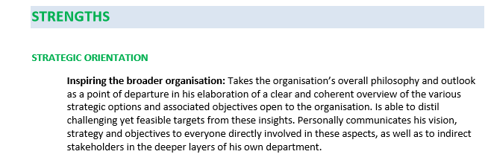

The second section presents a list of 5 areas for development with the development suggestions that may hinder the respondent in his personal growth as a leader, or even get in the way of his career development.

Example:
